**Internship Report**

**TECKNIK NEST**

**Week 6**

Muhammad Abdullah (B24F0513SE021)

**BS-SE BLUE (Fall-24)**

**School of Computing Sciences**

**Fachhochschule TECKNIK NEST**

**Internship Dates: 14th June – 31st July 2025**

Task 1:

Use math & statistics libraries to get square roots and average.

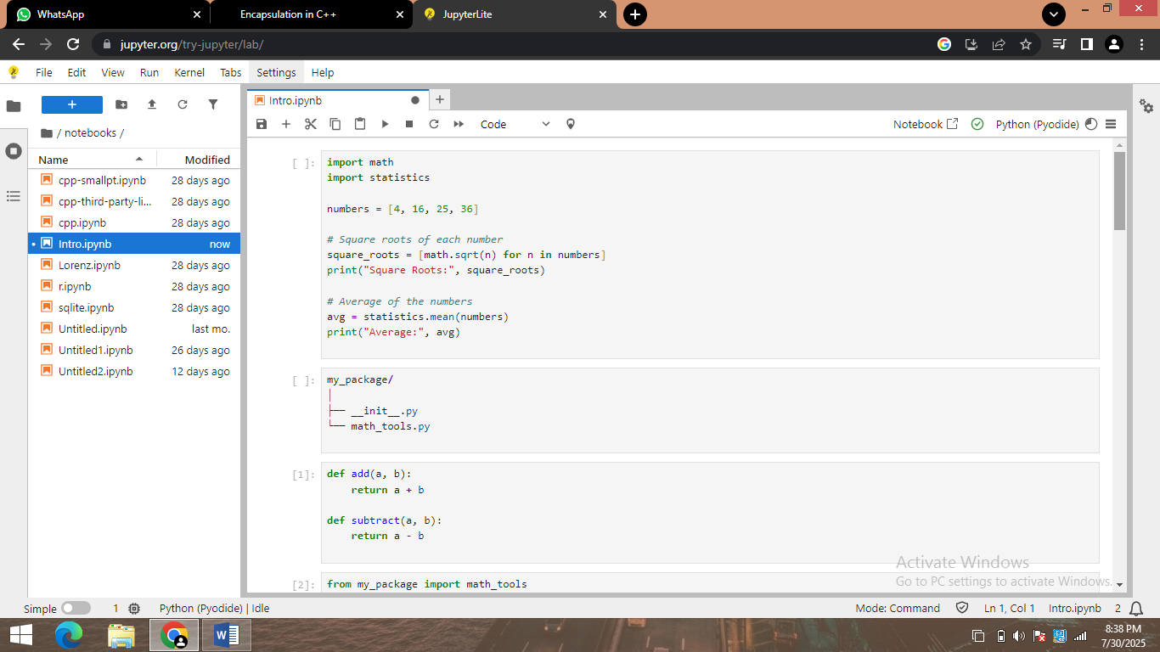

Task 2:

Create a custom package and import it in another script.



Task 3:

Create a virtual environment, install requests & numpy, and print their versions.

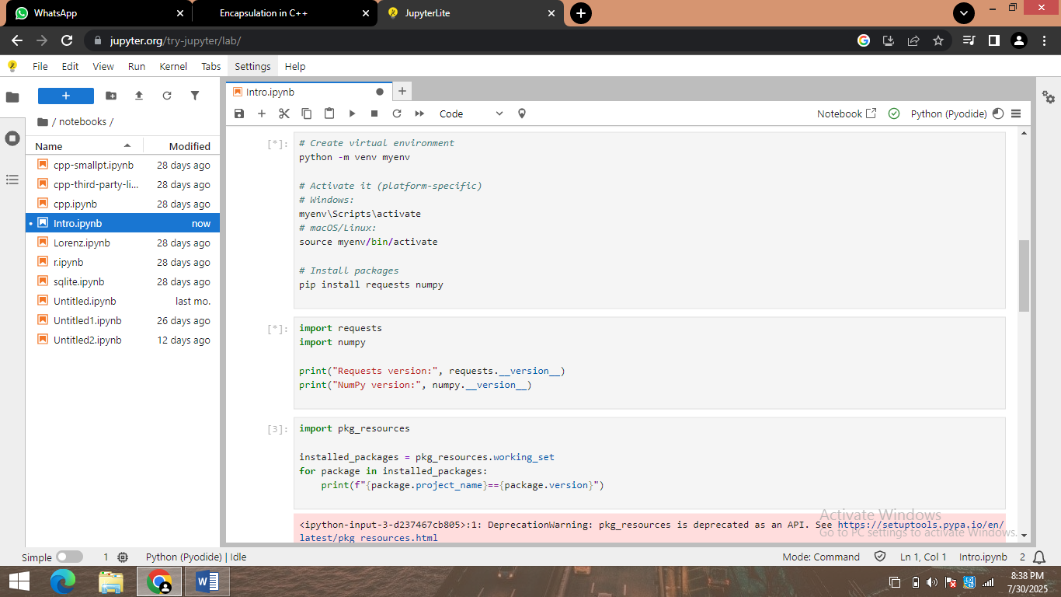

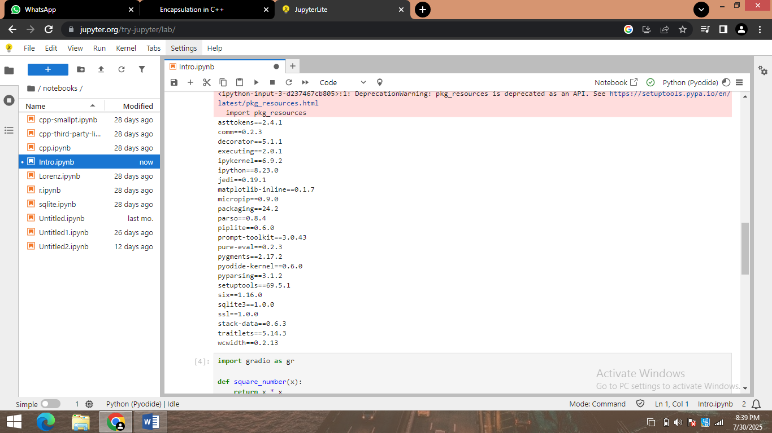

Task 4:

Print list of all installed pip packages from Python code.



Task 5:

Create Gradio app that takes a number and returns its square.

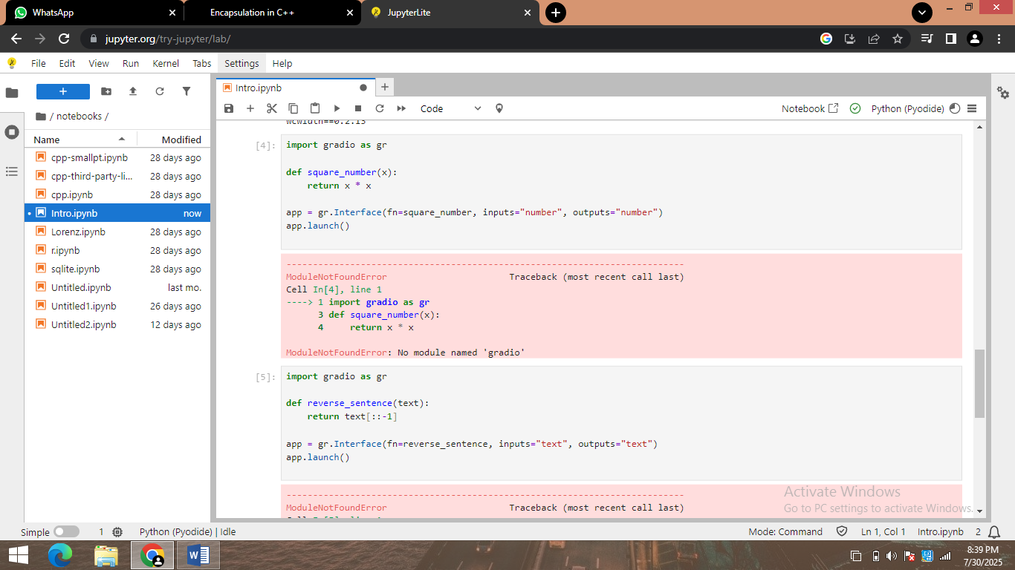

Task 6:

Create Gradio interface that takes a sentence and returns it reversed. 